CNNP Skill-1
G. Neha
2520030409
Step-1,2:
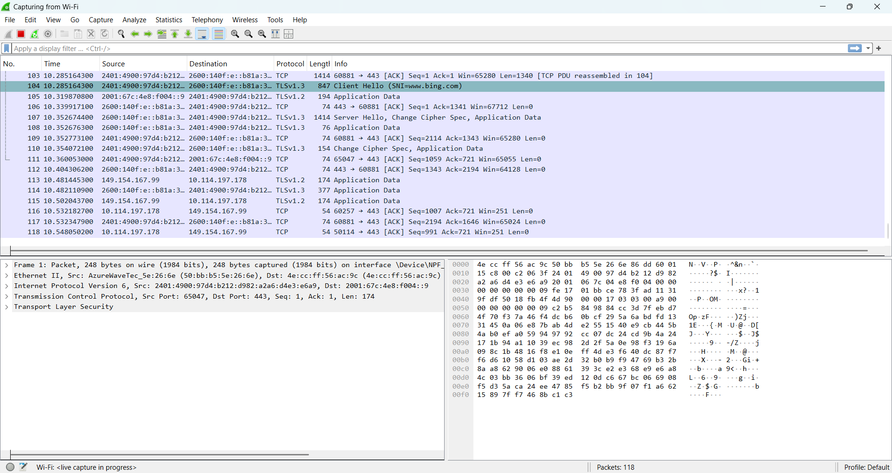
Step-3:
TCP:
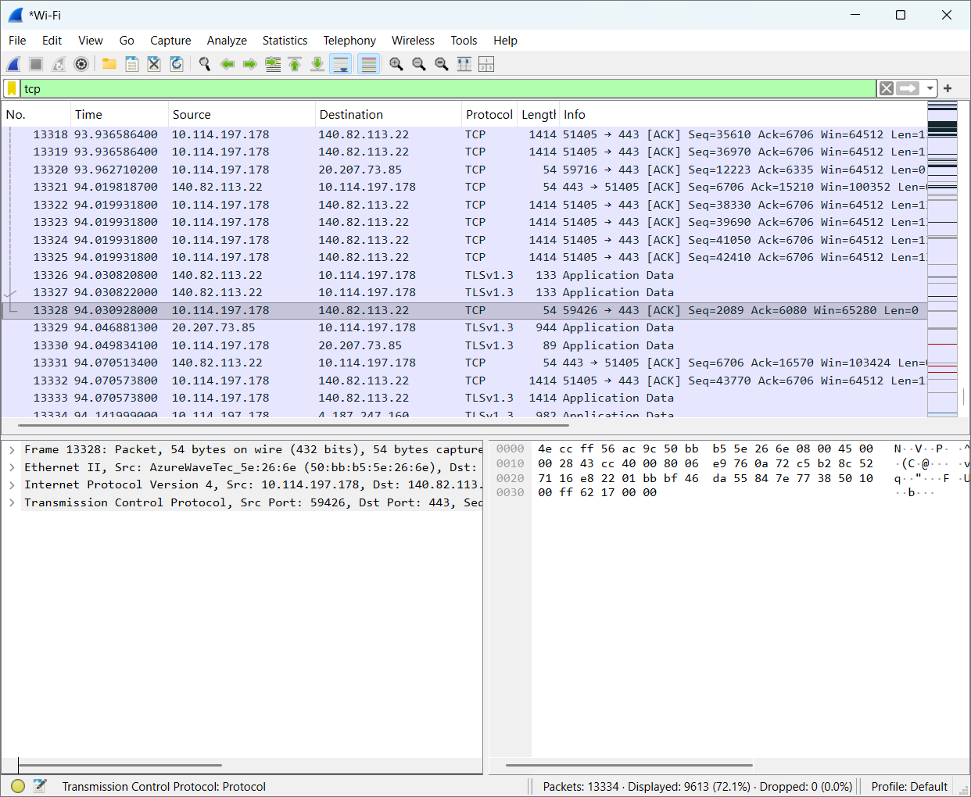
UDP:
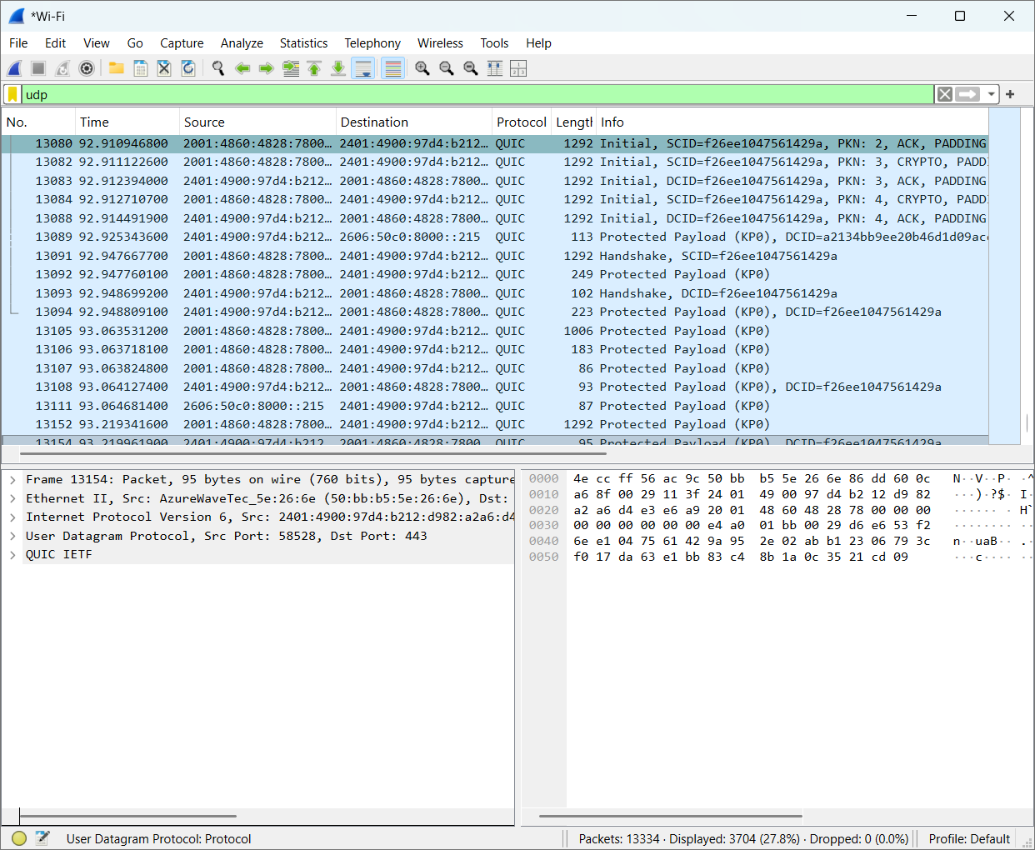

Frame:
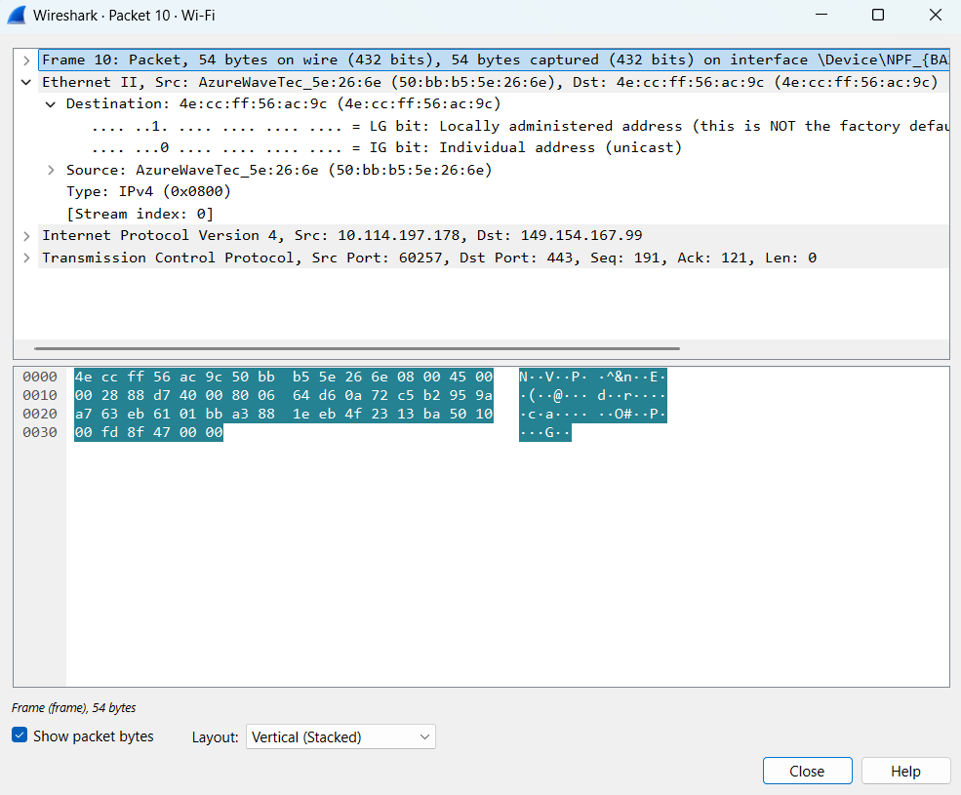

Ethernet:
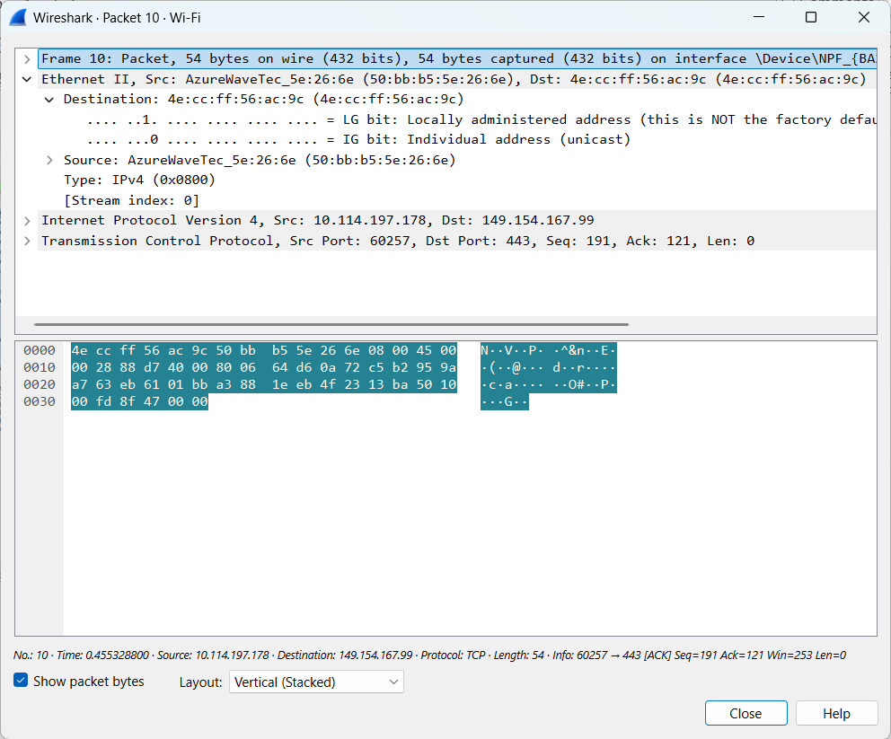
- Frame: 54 bytes
- Ethernet II: present
- IPv4: present
- TCP: present
- Source IP: 10.114.197.178
- Destination IP: 149.154.167.99
- Source port: 60257
- Destination port: 443
Udp:
1.Frame:
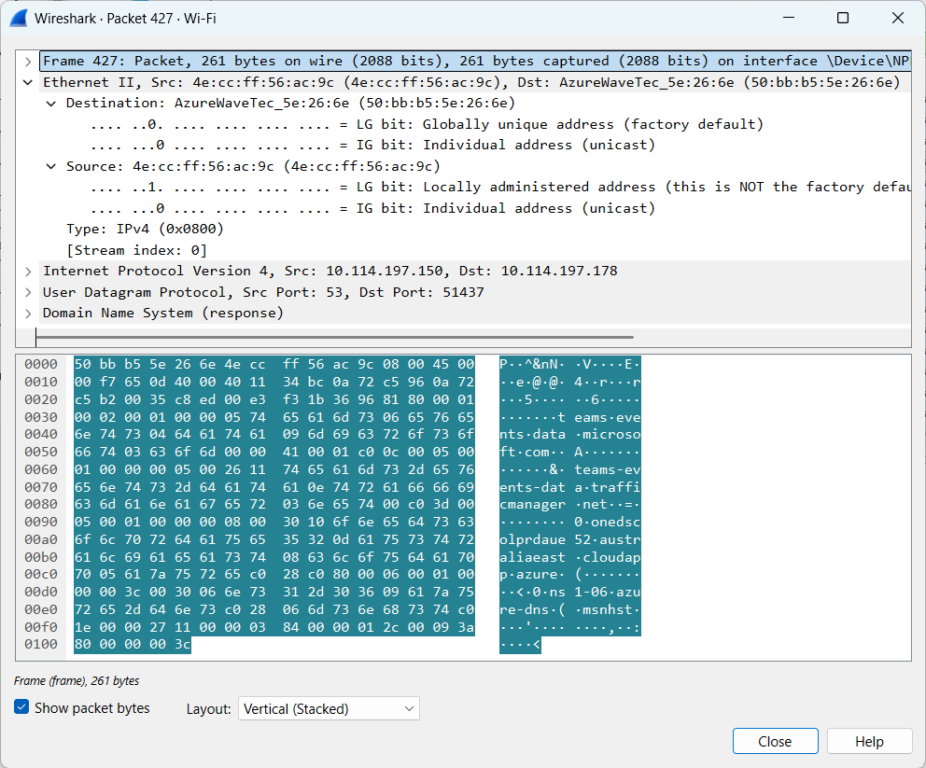
2.Ethernet:
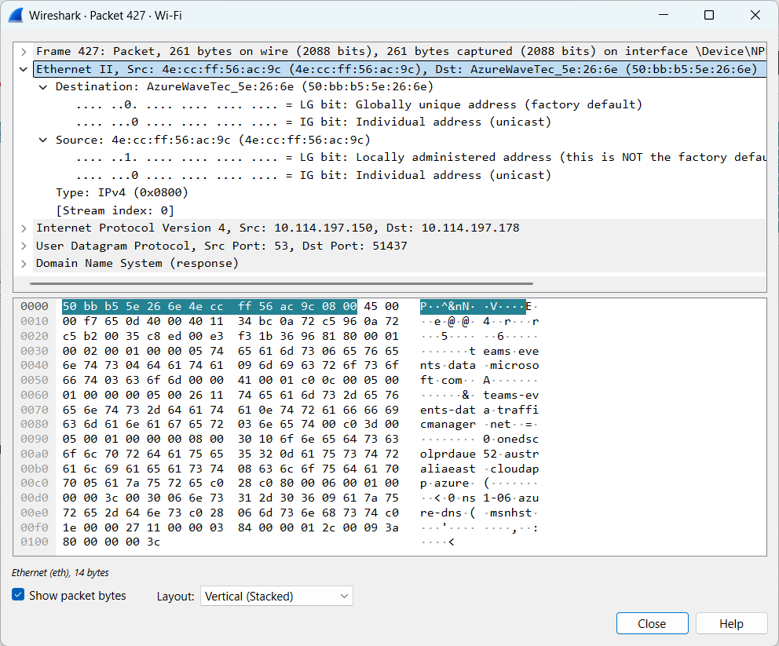
- Frame: 261 bytes
- Ethernet II: Present
- IPv4: Present
- UDP: Present
- Source IP: 10.114.197.150
- Destination IP: 10.114.197.178
- Source port: 53
- Destination port: 51437
Step-6:
Header Overhead = Ethernet + IPv4 + UDP
= 14 + 20 + 8

Payload Efficiency:
219/261 * 100 = 83.91%
Parameter | TCP packet | UDP packet
Frame length | 54 | 261
Ethernet Header Length | 14 | 14
IP Header Length | 20 | 20
Transport Header Length | 20 | 8
IP Total Length | 40 | 247
Transport Segment Length | 20 | 227
Payload Length | 0 | 219

Questions:
1. What is encapsulation?
Adding headers to data before sending it over a network is called Encapsulation.
2. What is the purpose of the Ethernet header?
It contains the source and destination MAC addresses.
3. What information is stored in the IP header?
Source IP, destination IP and packet length.
4. What is the difference between TCP and UDP headers?
TCP supports reliable data delivery, while UDP is simpler and faster.
5. Why does each protocol add a header?
To provide the information needed to send and receive data.
6. What is packet overhead?
Extra data added to a packet apart from the actual data.
7. How does header overhead affect network efficiency?
More overhead means less space for actual data, reducing efficiency.

